- Purpose
The purpose of this document is to describe the specifications developed for the patient demographics functions. The specifications include not only the data collection of patient medical history, but also the ability to search and find patient medical history information. The patient demographics will be used to track and store ClearView image and analysis data.

- General Requirements

Where appropriate, logic should be contained in try/catch blocks and any exceptions should be logged using the standard logging mechanisms.

- Specifications

General
Many of the services in the application run within the general client framework and can be accessed independently of the patient demographics. The General application framework is the overall framework of the application that provides authentication, navigation and integration services to other embedded services.
Assumptions and Dependencies
The user has logged into the system.
The user has appropriate permissions to enter the patient demographics.

  - Capture of patient demographics

These requirements are related to the workflow and process of capturing the patient demographics and persistence to the local storage.

Requirement #1: Users must be able to search for a patient in the system. All new patient entry must begin with the search screen. This is to ensure that there is not an existing patient.

Specification: The Manage Patient button is the only method to access the Patient Demographics. The first action is to open a Search Patient dialog box in order to determine if the patient already exists in the database.

Requirement #2: To search a patient, the user is prompted to enter at a minimum the patient’s first or last name. Additionally, search can be conducted by the patient’s birth date and gender in order to narrow the search results.

Specification: The Search Patient dialog bog requires the user to enter at least a portion of the first name, last name, birth date, and/or gender of the patient.

Requirement #3: The system displays zero or more results for the search criteria entered.

Specification: After clicking the Find button, the database returns all results that meet the search specifications. A message is displayed to notify the user if no records match the search criteria.

Requirement #4: If the appropriate patient is not found, then the user is presented with the ability to create a new patient profile.

Specification: Once the search results are returned, the Add Patient button is available in the Search Patient dialog box. The Add Patient button opens the Personal & Demographic window for initial data entry of patient information.

Requirement #5: If the patient is found, then the user is able to view the patient demographics information, capture a new scan for the patient selected, or enter a new patient profile.

Specification: Once the search results are returned with patients that meet the search criteria, users may select a specific patient listed and have the options to view the Patient Demographics information, Capture a new scan for the patient selected.

  - Completing entry of a new patient.

Requirement #6: The user will be prompted to enter patient’s remaining demographic information.

Specification: The Personal & Demographic tab is the first tab automatically displayed when the Add New Patient button is selected.

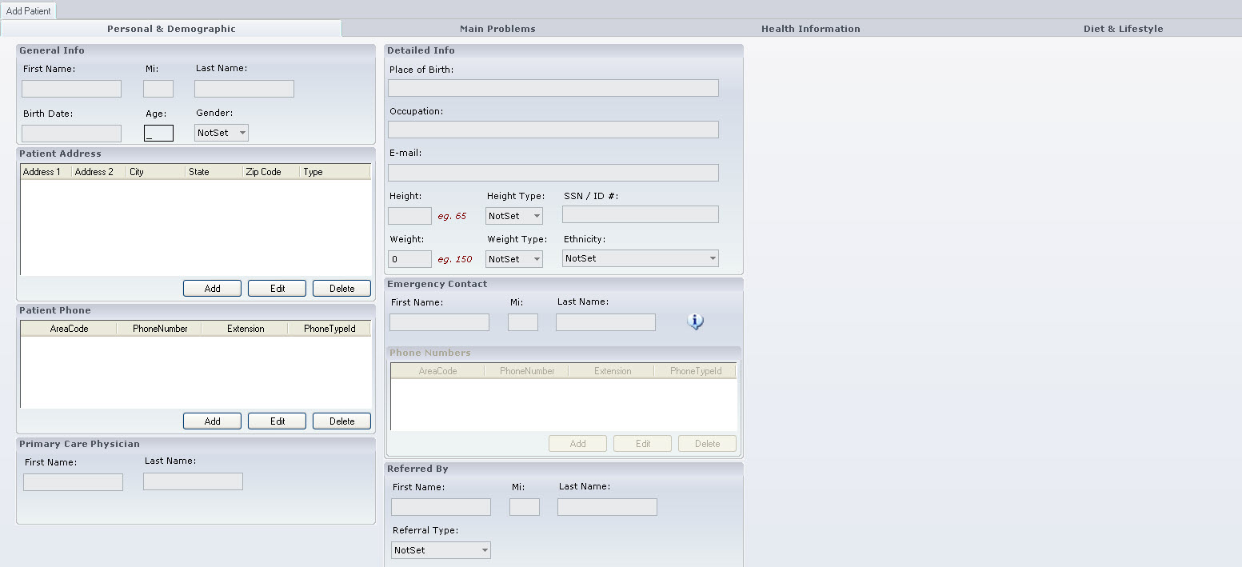

The Personal & Demographic tab contains data entry for the following:

- General Info (i.e., First Name, Middle Initial (i.e., “Mi”), Last Name, Birth Date, Age and Gender.
- A Patient Address control which allows for multiple addresses to be entered. The data points in this control are Address 1, Address 2, City, State, Zip Code, and Type (a unique identifier for each address such as Home, Work, etc.).

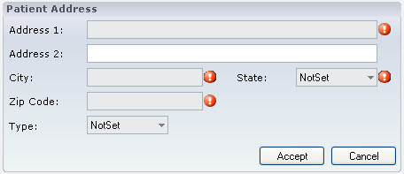

- A Patient Phone control which allows for multiple phone numbers to be entered. The data points in this control are Area Code, Phone Number, Extension, and Phone Type ID (a unique identifier for each phone number such as Home, Work, etc.).
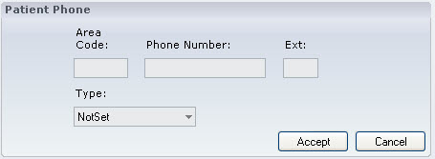

- Primary Care Physician including data points for First Name and Last Name.
- Detailed Info such as Place of Birth, Occupation, E-mail, Height, Height Type, SSN/ID#, Weight, Weight Type, and Ethnicity.
- An Emergency Contact control which allows for multiple Emergency Contacts to be entered. The data points in this control are First Name, Middle Initial (“Mi”), Last Name and an internal control to enter Phone Numbers which include the data points Area Code, Phone Number, Extension and Phone Type ID (a unique identifier for each phone number such as Home, Work, etc.).
- Referred by including data points for First Name, Middle Initial (“Mi”), Last Name and Referral Type (as a drop down menu which includes Friend, Physician, Family Member, Acupuncturist, Nutritionist, Chiropractor, and Other).

Requirement #7: The user will be prompted to enter patient’s Main Problem(s) including the following:

  - Effect on daily activities.
  - Duration of symptoms and Diagnosis details.
  - Treatments, effectiveness of treatments. Whether or not the patient has tried Acupuncture or Chinese herbal medicines.

Specification: The Main Problems tab is displayed when the Add New Patient button is selected. The Main Problems tab provides a control to enter the main problems of the patient.

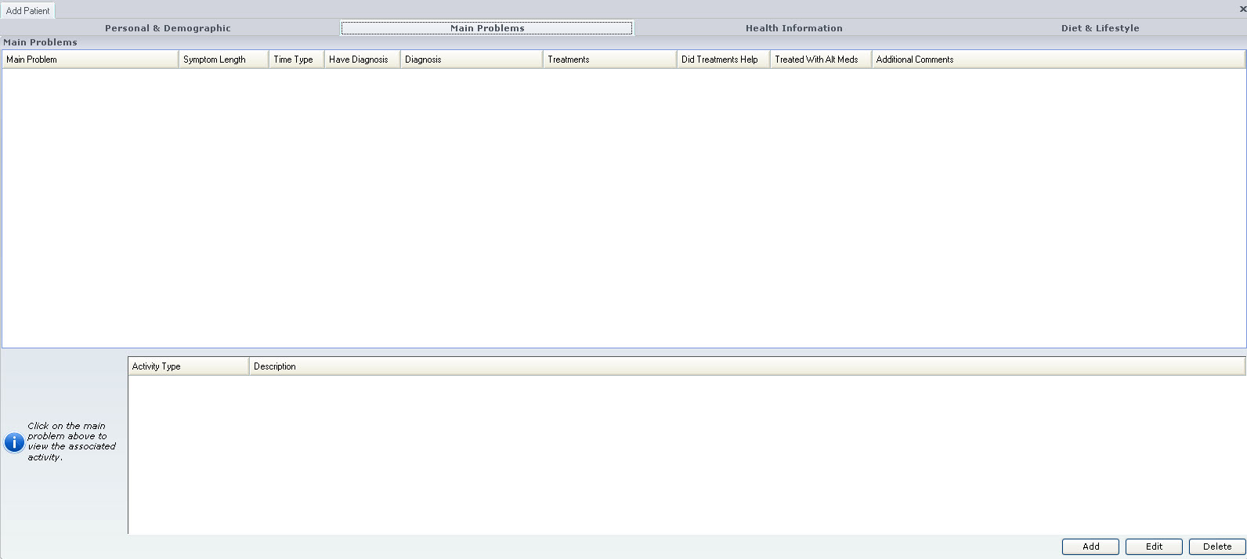

Clicking the Add button provides the user with the Main Problems General Info and Additional Info controls.

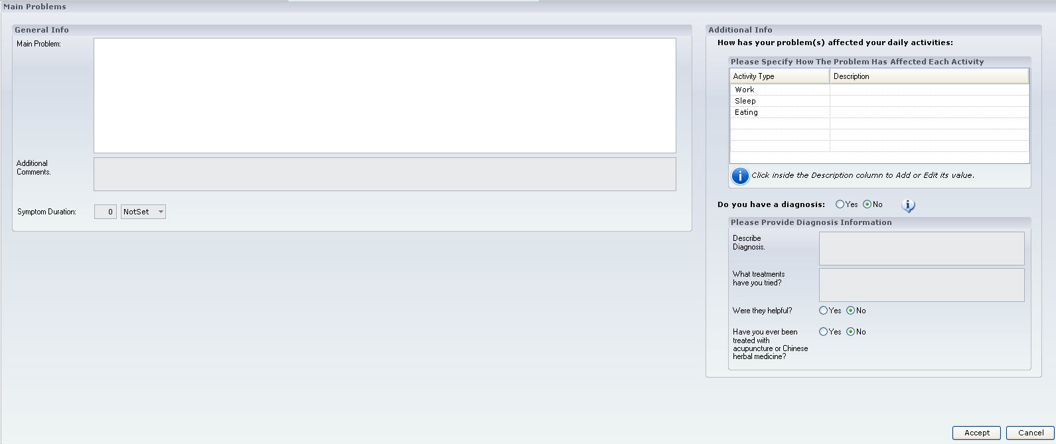

- General Info control which allows for multiple Main Problems to be entered. The data points in this control are Main Problem, Additional Comment and Symptom Duration which provides a method for record a numerical duration and a drop down menu of units (i.e., days, months, years).
- Additional Information control which contains data points regarding each Main Problem. in this control are data points to record How the Problem Affects Daily Activities (text box) with specific entry points for Work, Sleep, and Eating. Additional data points include Yes/No data point Do You Have a Diagnosis?, text box to Describe Diagnosis, text box to record Treatments Tried, Yes/No data points for whether the treatments tried were Helpful and whether acupuncture or Chinese medicine treatments have been tried.

Requirement #8: The user will be prompted to enter patient’s Past Medical History.

Specification: The Health Information tab is displayed when the Add New Patient button is selected. The Health Information tab provides a control to enter the several areas of Health Information. Sub-tabs displayed under the Health Information tab include Medical History, Family History, Previous Conditions, Physical, Psychological & Chemical, Reproductive System, and Additional Comments.

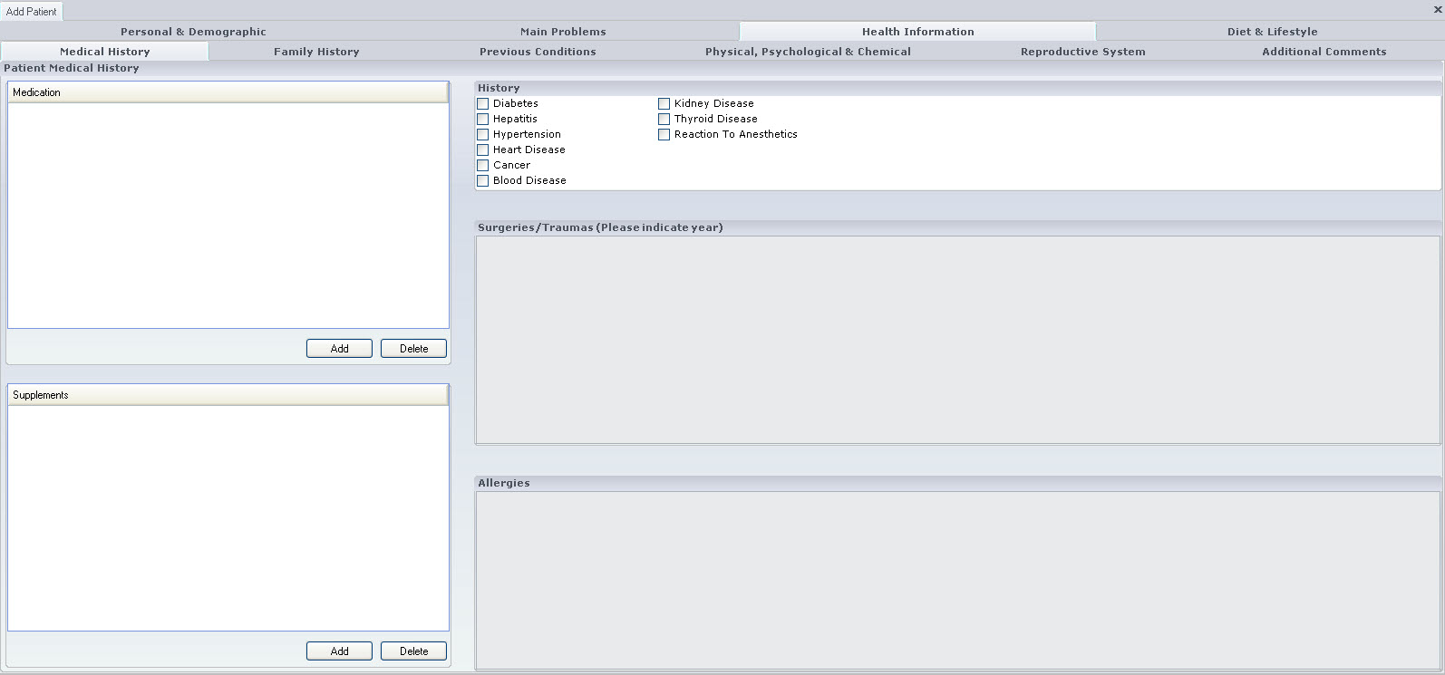

Requirement #9: The user will be prompted to enter patient’s Past Medical History including the following:

- Allergies.
- Surgeries with Dates.
- History of diabetes / Hepatitis / Hyper Tension / Heart Disease / Cancer.
- List of all Medications/Supplements- The user will be able to select from a list provided on the screen of medications taken in the last two months (multiple choice). This will also include a selection of “Other” and the ability to enter a description of what “Other” is. This differs from the include example intake form where the entries are textual.

Specification: The Medical History sub-tab is displayed when the Add New Patient button is selected. The Medical History sub-tab provides a control to enter the Patient Medical History including:

- Medication control which provides data entry of medications from a specified Medications List. The control provides a method for searching the Medications List which includes a data entry field and a Find button. The Medications List provides the name of the medication and can contain the dosage/method of use. Medications are added to the Patient Medication List using the Add button and removed from the Patient Medication List using the Remove button. The control provides a method to save the Patient Medication List using the Accept button or to not save the Patient Medication List using the Cancel button.

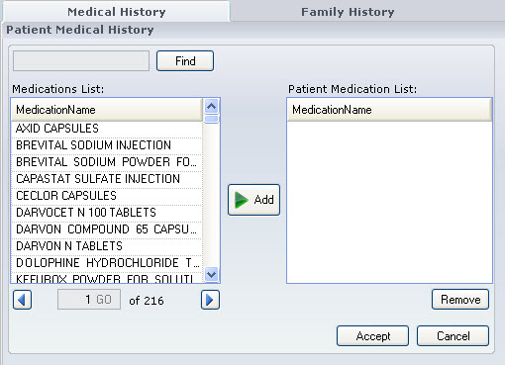

- Supplements control which provides data entry of medications from a specified Supplements List. The control provides a method for searching the Supplements List which includes a data entry field and a Find button. The Supplements List provides the name of the Supplement. Supplements are added to the Patient Supplements List using the Add button and removed from the Patient Supplements List using the Remove button. The control provides a method to save the Patient Supplements List using the Accept button or to not save the Patient Supplements List using the Cancel button.
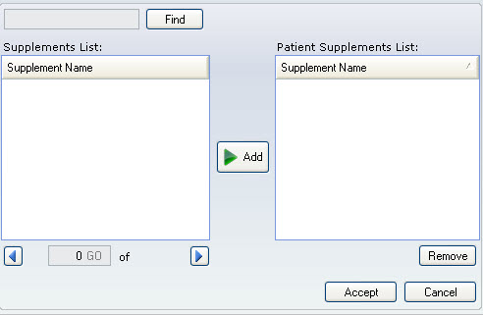

- History check box entry of history of diabetes, Hepatitis, Hypertension, Heart Disease, Cancer, Blood Disease, Kidney Disease, Thyroid Disease, Reaction to Anesthetics.

- Text box entry of Surgeries/Traumas (Please indicate year).

- Text box entry of Allergies

Requirement #10: The user will be prompted to enter patient’s Family history of diabetes, Heart Disease, High Blood pressure, blood disease, kidney disease, thyroid disease, reaction to anesthetics and cancer.

Specification: The Family History sub-tab is displayed when the Add New Patient button is selected. The Family History sub-tab provides a list of Disease Types with check boxes to indicate the family member with the history of disease type.

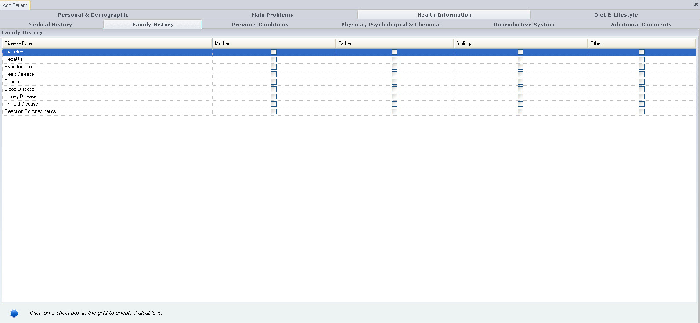

Requirement #11: The user will be prompted to enter patient’s Conditions experienced within past six months.

Specification: The Previous Conditions sub-tab is displayed when the Add New Patient button is selected. The Previous Conditions sub-tab provides check boxes to indicate which of the displayed conditions were previously experienced:

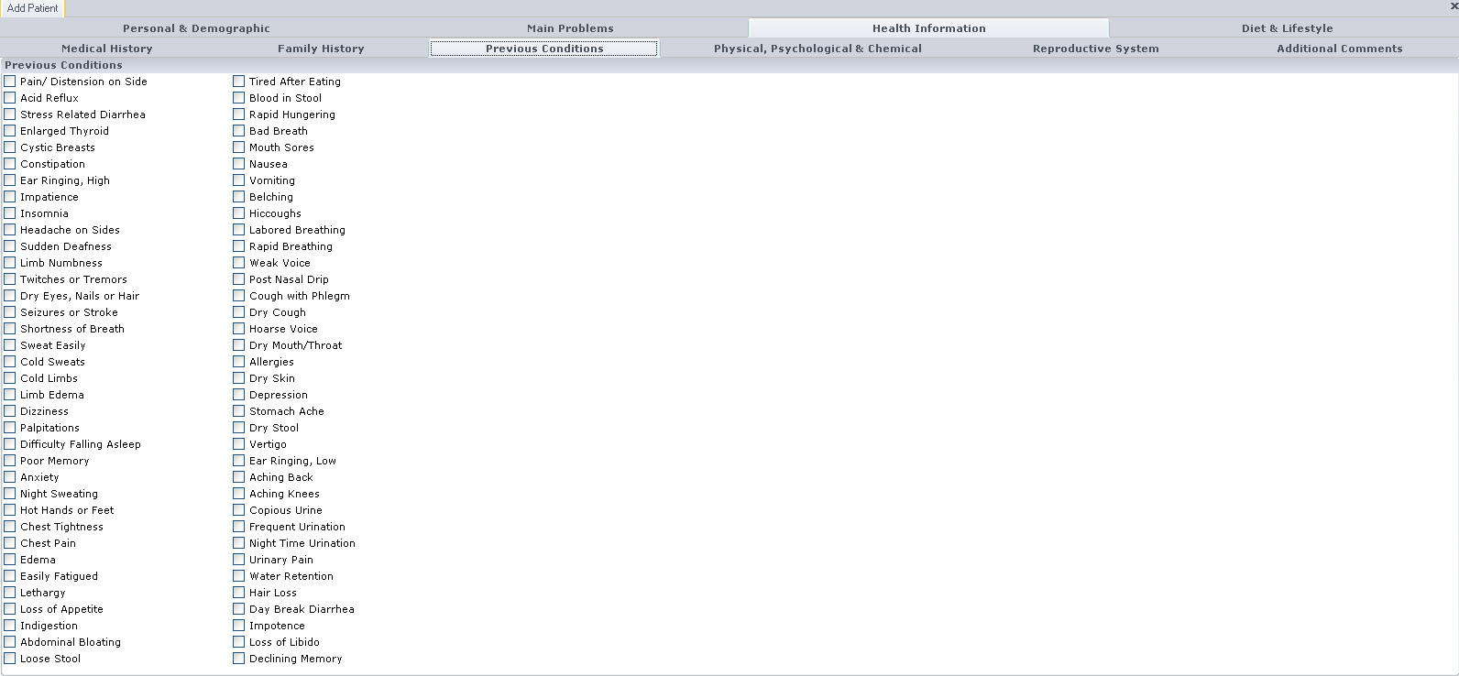

- Requirement #12: The user will be prompted to enter patient’s unusual physical job demands, psychological stress and/or chemical exposure at work or home.

Specification: The Physical, Psychological & Chemical sub-tab is displayed when the Add New Patient button is selected. The Physical, Psychological & Chemical sub-tab provides a text box with the Title “Unusual Physical Demands, Psychological Stress and/or Chemical Exposure” and the instruction “Please list history of depression and emotional trauma”.

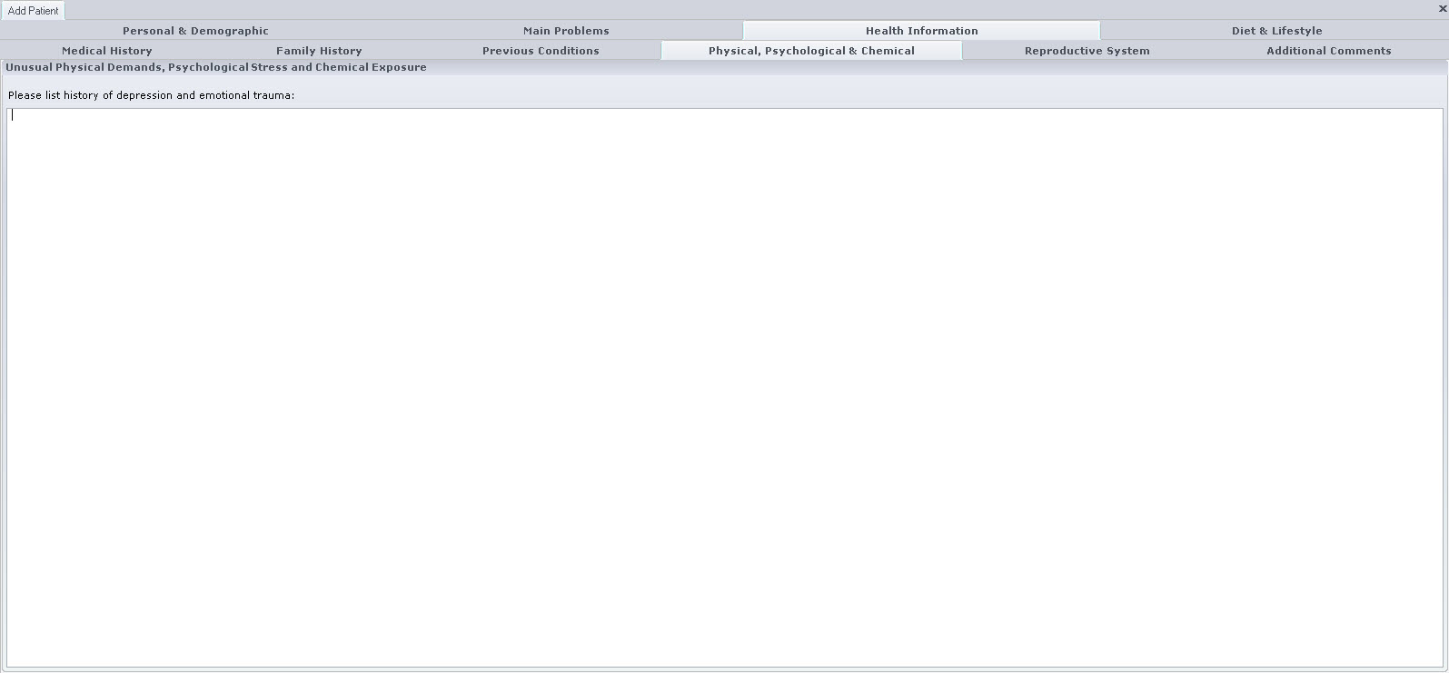

Requirement #13: The user will be prompted to enter information on the reproductive system for the patient.

Specification: The Reproductive System sub-tab is displayed when the Add New Patient button is selected. The Reproductive System sub-tab provides data entry specific to the reproductive system for male and female patients.

- When the gender entered in Patient Demographics is selected not selected, this sub-tab displays no data entry points.

- When the gender entered in Patient Demographics is selected as Male, the sub-tab provides check boxes to indicate whether the patient has experienced Premature Ejaculation, Excessive Sexual Drive, Active Sexual Life, weak Erection, Loss of Sexual Drive, Impotence, and Emission.

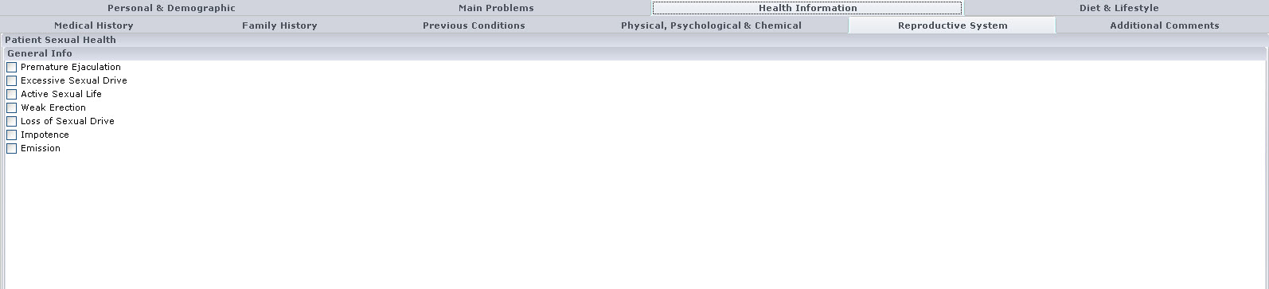

- When the gender entered in Patient Demographics is selected as Female, the sub-tab provides check boxes to indicate the patient’s General Sexual Health Info including all those listed in the image below (e.g., Regular Cycles, Delayed Cycles, etc.).

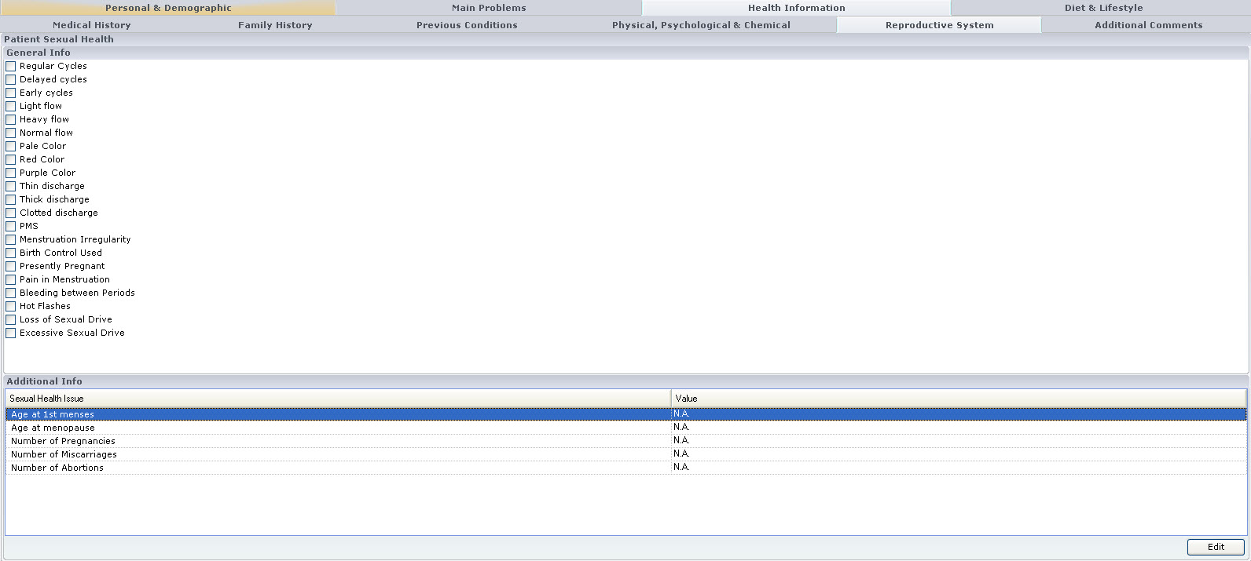

  - The sub-tab also contains an Additional Info control which lists Sexual Health Issues specific to female patients. The Ages at 1st Menses, Age at Menopause, Number of Pregnancies, Number of Miscarriages, Number of Abortions are listed. Each data point opens to display the numerical data entry box. Examples of each display are listed below:

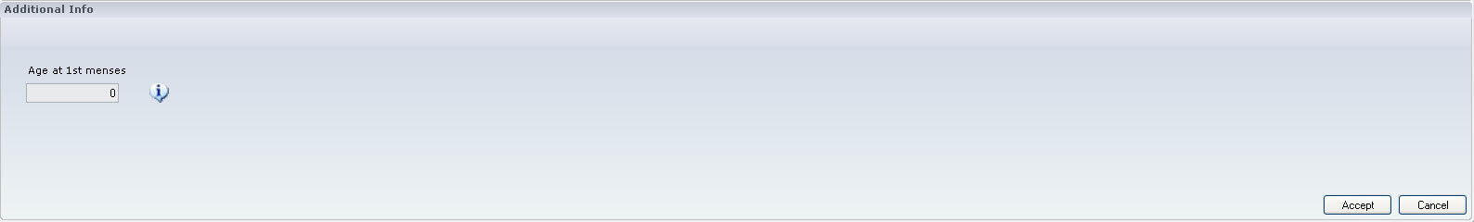
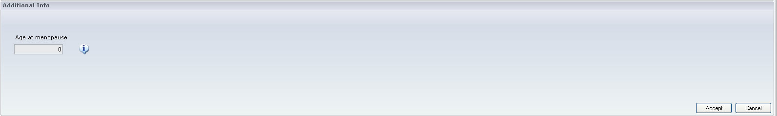

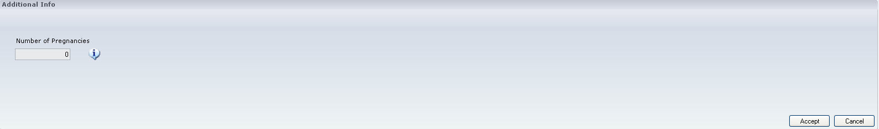

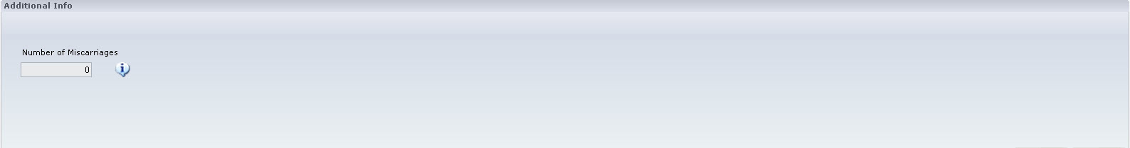

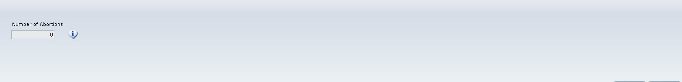

Requirement #14: The user will be prompted to enter additional comments or information related to patient’s health.

Specification: The Additional Comments sub-tab is displayed when the Add New Patient button is selected. The Additional Comments sub-tab provides a text box to enter any additional comments regarding the patient’s health.

Requirement #15: The user will be prompted to enter patient’s average daily food intake information.

Specification: The Diet & Lifestyle tab is displayed when the Add New Patient button is selected. The Diet & Lifestyle tab displays two different sub-tabs- Average Daily Food Consumption and Nicotine, Caffeine & Alcohol Consumption. The Average Daily Food Consumption sub-tab provides a list of Meal Types (i.e., 1st Meal, 2nd Meal, 3rd Meal, 4th Meal, 5th Meal, and Snacks) and the Description entered for each.

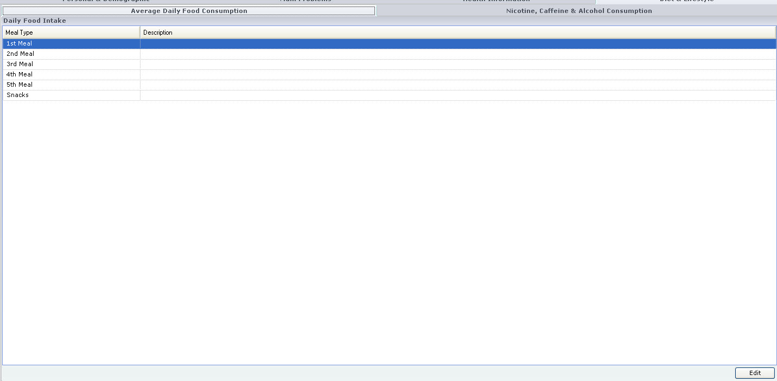

Double clicking on the Meal Type opens a Daily Food Intake text box labeled for the selected Meal Type. An example of this display:

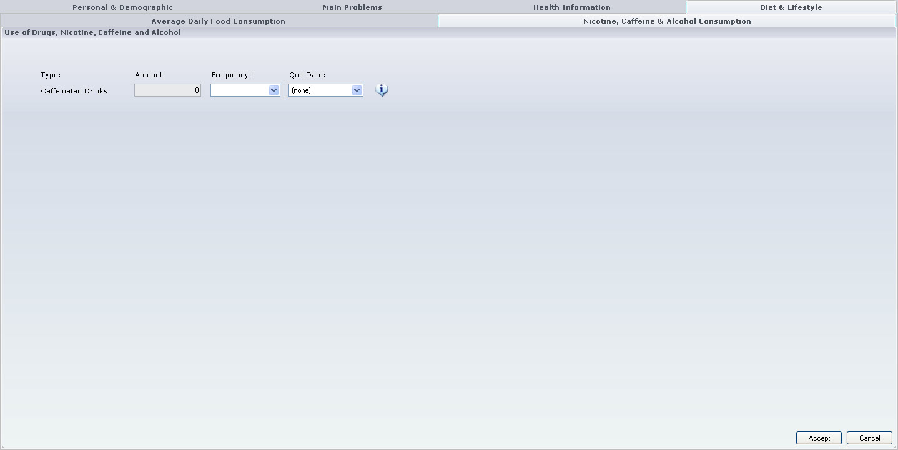

Requirement #16: The user will be prompted to enter patient’s Information on intake of Tobacco/Nicotine, Caffeinated drinks, Alcoholic beverages and drugs and also if they have quit, the date when the quit consuming these products.

Specification: The Nicotine, Caffeine & Alcohol Consumption sub-tab is displayed when the Add New Patient button is selected. The Nicotine, Caffeine & Alcohol Consumption sub-tab provides a control to enter the consumption of nicotine, caffeine and alcohol of the patient.

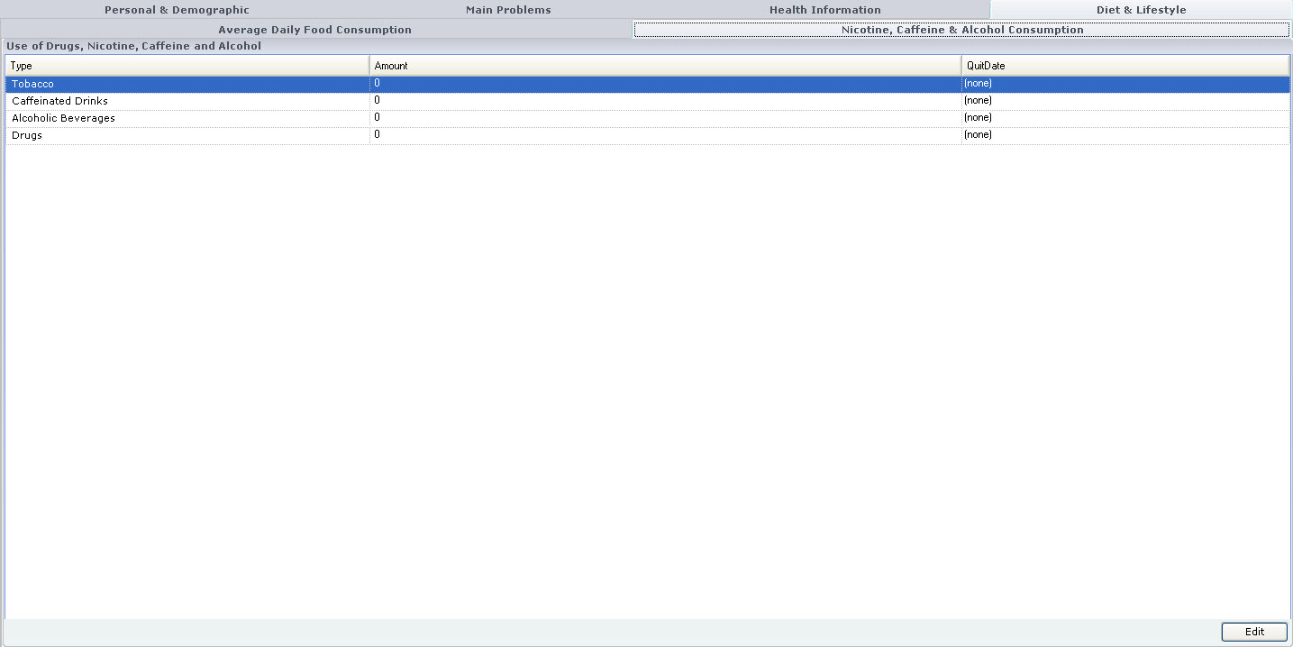

- The Nicotine control provides data entry of the numerical amount of tobacco used, a drop down menu to select the frequency of use, and a drop down menu to select the quit date.

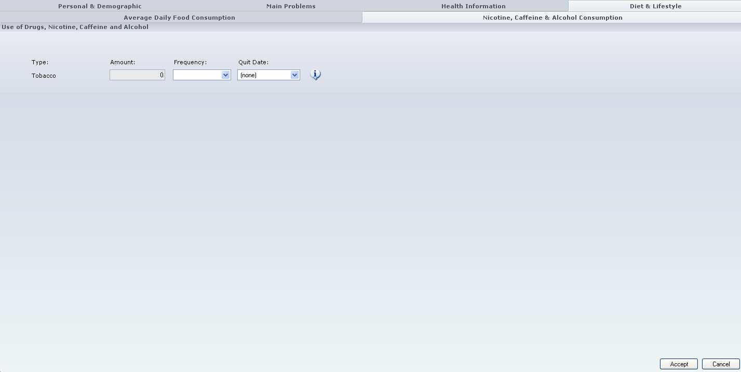

- The Caffeinated Drinks control provides data entry of the numerical amount of caffeinated drinks consumed, a drop down menu to select the frequency of consumption, and a drop down menu to select the quit date.

- The Alcoholic Beverages control provides data entry of the numerical amount of Alcoholic Beverages consumed, a drop down menu to select the frequency of consumption, and a drop down menu to select the quit date.

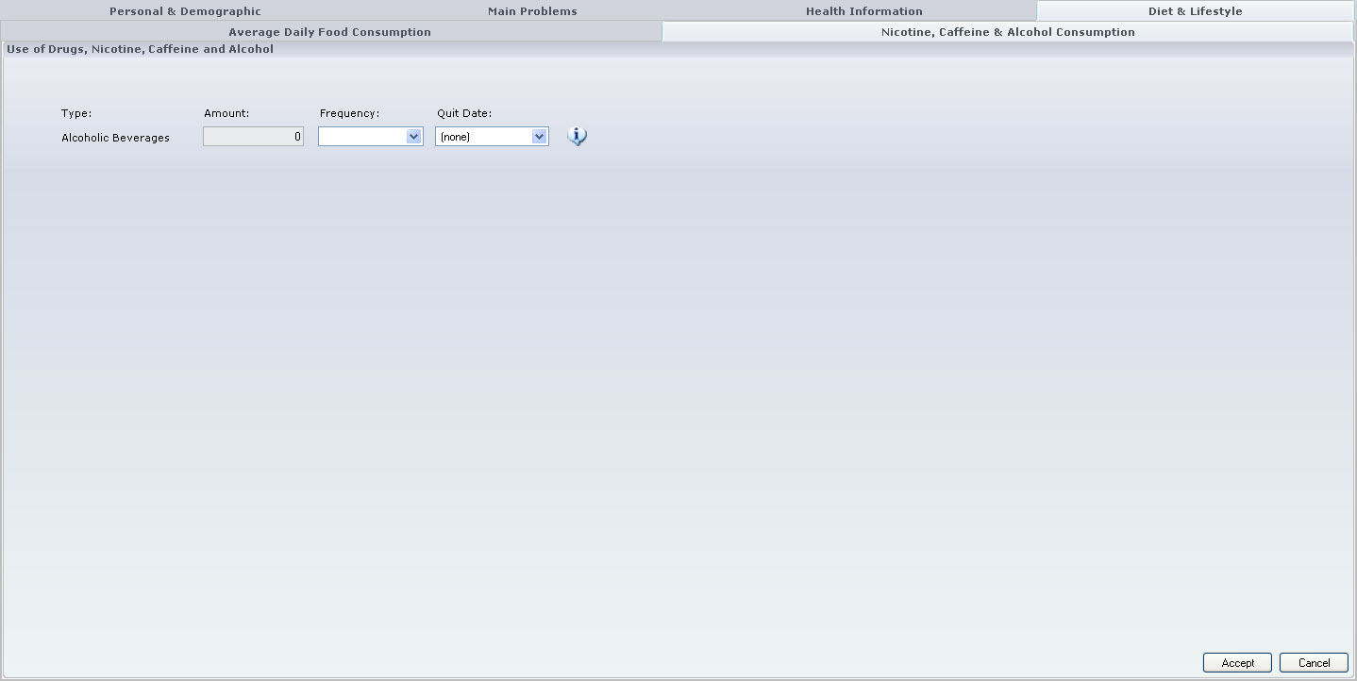

- The Other control provides data entry of the numerical amount of drugs used, a drop down menu to select the frequency of use, and a drop down menu to select the quit date.

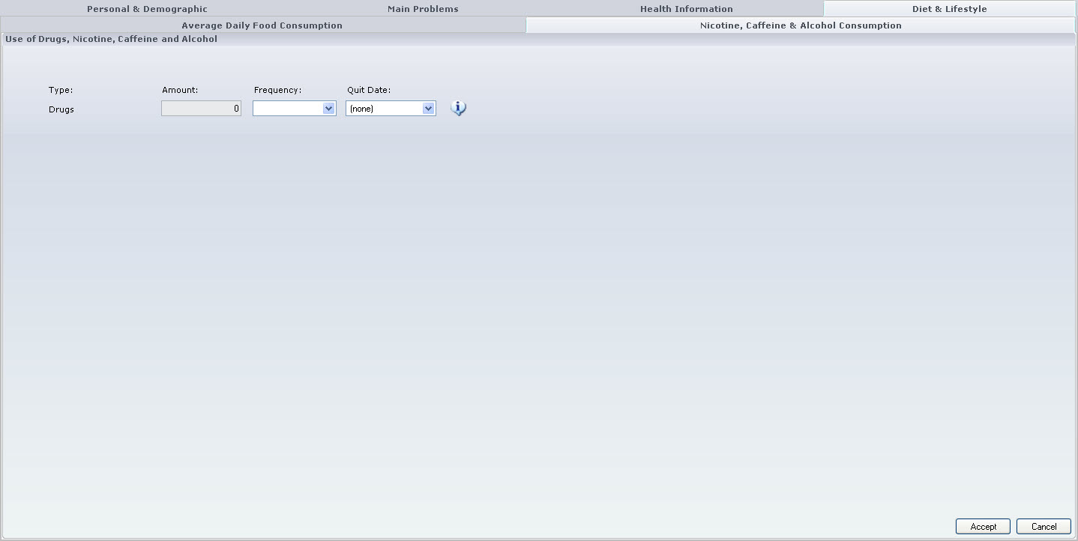

Requirement #17: The user can either cancel out of the process (Cancel) or they can save the information (Save).

Specification: A Save button is always displayed at the top left of the screen (persisted display no matter which tab/sub-tab is displayed. This button will save the patient demographic information entered as long as the First Name, Last Name, Birth Date, and Gender have data entered. These four minimum required data points must have data in order to save a patient demographic and/or conduct a scan. The data entry process can be cancelled at any time by clicking the “X” in the upper right corner of the tabs. If the Save button is selected, the data will be saved and the tab will be closed. If the Cancel button is selected, the data is not saved and tab is closed.

Requirement #18: All data will be saved on the local system located at the client location. This includes all information contained on the patient intake form and the unique identifier generated based upon the patients name, date of birth and gender.

Specification: All data is saved in a local SQL Server database located on the same device as the ClearView application. There is no data that is not stored locally, a backup and synchronization process which will synchronize report data only to the Epic Central server is yet to be written. This process, when complete, will transfer only calculated and collected (non-demographic data). A unique identifier is established to tie the data back to the demographics on the client as necessary.

  - Editing an existing patient.

Requirement #19: In order to update a patient record the same procedure is used to retrieve the record through the search functionality outlined above.

Specification: The patient demographics can be retrieved using the Search function described in Requirements #1, #2, and following. The Search function control provides a button View Patient which retrieves patient demographics and displays all data entered in the appropriate tabs/sub-tabs.

Requirement #20: A user can add to or update any of the existing patient’s information listed above.

Specification: The patient demographics can be retrieved using the Search function described in Requirements #1, #2, and following. The Search function control provides a button View Patient which opens all of the patient demographics tabs/sub-tabs and allows the data entered to be edited, additional information entered, and obsolete/incorrect data to be deleted.

Patient Demographic Information- Specific Data Points and Functional format (highlighted in red)

Name: (required – auto populated from patient search screen)
Street: (Text) |  | City: (Text) |  | State: |  | Zip: (Text)
Birth date: (required – auto populated from patient search screen) | Age: (Calculated) |  | Place of Birth: (Text) |  | Gender (M\F option)
Height: (Text) | Weight: (Text) |  | E-mail: (Text)
Home Phone: (Text) |  |  | Cell Phone: (Text)
Occupation: (Text) |  |  | Social Security #:(Text)
Emergency Contact: (Text) |  |  | Phone: (Text)
Referred By: (Text) |  |  | Friend Physician Family Member Acupuncturist  Nutritionist Chiropractor Other (Single-Option Select)
Family Physician: (Text) |  |  | Address: (Text)

Main Problems the Patient would like to address
Main Problem(s): (Text)
Has your problem(s) affected your daily activities: YES NO IF YES PLEASE SPECIFY:
WORK HOW? (Checkbox)(Text)
SLEEP HOW? (Checkbox)(Text)
EATING HOW? (Checkbox)(Text)
How long have you had symptoms: (Text) Days (Text) Wks (Text)  Months(Text)Yrs(Text) | Do you have a diagnosis? YES NO (Single-Option Select)
Describe Diagnosis: (Text)
What treatments have you tried? (Text)
Were they helpful? YES NO (Single-Option Select)
Have you been treated with acupuncture or Chinese herbal medicine? YES NO (Single-Option Select)

Past Medical History
ALLERGIES: (Text)
SURGERIES/TRAUMAS: (NOTE YEAR FOLLOWING DESCRIPTION): (Text)
Please check if you have a history of:  (Multi-Option Select) | Diabetes | Hepatitis | Hypertension | Heart Disease | Cancer
List all Medications, Vitamins & Herbs Taken within the last two (2) months:

Unusual Physical Demands, Psychological stress, Chemical Exposure
(Text)

DESCRIBE YOUR AVERAGE DAILY FOOD INTAKE:
1ST Meal | 2nd Meal | 3rd Meal | 4th Meal | 5th Meal | Snacks
(Text -- All)

Use of Drugs, Nicotine, Caffeine and Alcohol
 | Tobacco/Nicotine | Caffeinated Drinks | Alcoholic Beverages | Drugs
TYPE | (Text)
AMOUNT | (Text)
QUIT? MO/YR | (Month DropDown)  (Year Drop Down)

Family History
 | MOTHER | FATHER | SIBLINGS | OTHER
DIABETES | (CheckBox -- all)
HEART DISEASE
HIGH BLOOD PRESSURE
BLOOD DISEASE
KIDNEY DISEASE
THYROID DISEASE
REACTION TO ANESTHETICS
CANCER

Previous Conditions
 | Pain/ Distension on Side  (CheckBox -- all) |  | Shortness of Breath |  | Easily Fatigued |  | Labored Breathing |  | Vertigo
 | Acid Reflux |  | Sweat Easily |  | Lethargy |  | Rapid Breathing |  | Ear Ringing, Low
 | Stress Related Diarrhea |  | Cold Sweats |  | Loss of Appetite |  | Weak Voice |  | Aching Back
 | Enlarged Thyroid |  | Cold Limbs |  | Indigestion |  | Post Nasal Drip |  | Aching Knees
 | Cystic Breasts |  | Limb Edema |  | Abdominal Bloating |  | Cough with Phlegm |  | Cold Limbs
 | Constipation |  | Dizziness |  | Loose Stool |  | Dry Cough |  | Copious Urine
 | Ear Ringing, High |  | Palpitations |  | Tired After Eating |  | Hoarse Voice |  | Frequent Urination
 | Impatience |  | Difficulty Falling Asleep |  | Blood in Stool |  | Dry Mouth/Throat |  | Night Time Urination
 | Insomnia |  | Poor Memory |  | Rapid Hungering |  | Allergies |  | Urinary Pain
 | Headache on Sides |  | Anxiety |  | Bad Breath |  | Dry Skin |  | Water Retention
 | Sudden Deafness |  | Night Seating |  | Mouth Sores |  | Depression |  | Hair Loss
 | Limb Numbness |  | Hot Hands or Feet |  | Nausea |  | Difficulty Falling Asleep |  | Day Break Diarrhea
 | Twitches or Tremors |  | Chest Tightness |  | Vomiting |  | Stomach Ache |  | Impotence
 | Dry Eyes, Nails or Hair |  | Chest Pain |  | Belching |  | Dry Stool |  | Loss of Libido
 | Seizures or Stroke |  | Edema |  | Hiccoughs |  |  |  | Declining Memory

Additional Comments about Health
(Text)

Sexual Health. Only applicable section will be available depending upon gender section.

FOR WOMEN ONLY:
Age at 1st menses  (CheckBox – all – on\off\null) |  | Pale Color |  | Number of Pregnancies
Age at menopause |  | Red Color |  | Number of Miscarriages
If menstruating: Regular Cycles |  | Purple Color |  | Number of Abortions
Delayed cycles |  | Thin discharge |  | Birth Control Used
Early cycles |  | Thick discharge |  | Presently Pregnant
Light flow |  | Clotted discharge |  | Pain in Menstruation
Heavy flow |  | PMS |  | Bleeding between Periods
Normal flow |  | Menstruation Irregularity |  | Hot Flashes

FOR MEN ONLY:
Premature Ejaculation  (CheckBox – all – on\off\null) |  | Weak Erection |  | Impotence
Excessive Sexual Drive |  | Loss of Sexual Drive |  | Emission
Active Sexual Life |  | Masturbation

Document Revision History
Version Number: | Description of Change: | Date: | Updated by:
000 | Introduction | 5/24/11 | A. Mason

